**GOVERNMENT OF TAMILNADU**

**Naan Mudhalvan – Project Based Experiential Learning**

Project Report on

**SUBSCRIBERS GALORE : EXPLORING WORLD’S TOP YOUTUBE CHANNELS**

**Submitted by**

**GOKILAVANI .M : BA611FE8639D6AB99CD49036EDA78463**

**SWETHA .M : CEA971903C7B455AA2443A16455F0859**

**RENGANAYAKI.R: BBA605B9997949C86A44DF2540521810**

**JEYANTHI .N : 18469790DB7D6DB9CAD4E9D13E6F545D**

**(TEAM ID : NM2023TMID07191**

**)**

**Under the guidance of**

**Dr. M. GAYATHRI M.Sc., Ph.D**

**Guest Lecturer**

**Department of Mathematics**

GOVERNMENT ARTS COLLEGE FOR WOMEN,

(Affiliated to Mother Teresa Women’s University, Kodaikanal)

Reaccredited with “C” Grade by NAAC

NILAKOTTAI-624 208

1 INTRODUCTION

1.1 Overview

A subscriber to a channel on the video-sharing YouTube is a user who has chosen to receive the channel's content by clicking on that channel's "Subscribe" button, and each user's subscription feed consists of videos published by channels to which the user is subscribed. The ability to subscribe to users was introduced in October 2005. YouTube began publishing a list of its most-subscribed channels in April 2006. An early archive of the list dates to May 2006. The following table lists the 50 most-subscribed YouTube channels, as well as the primary language and content category of each channel. The channels are ordered by number of subscribers; those whose displayed subscriber counts are identical are listed so that the channel whose current growth rate indicates that its displayed subscriber count will exceed that of the other channel is listed first. Automatically generated channels that lack their own videos (such as Music and News) and channels that have been made effectively obsolete as a result of the transferal of their content (such as Justin Bieber VEVO and Taylor Swift VEVO) are excluded. As of February 2023, 21 of the 50 channels listed primarily produce content in English while 16 primarily produce content in Hindi. All 50 of the channels have surpassed 40 million subscribers, 39 of them have surpassed 50 million subscribers, 23 of them have surpassed 60 million subscribers, 16 of them have surpassed 70 million subscribers, 12 of them have surpassed 80 million subscribers, 10 of them have surpassed 90 million and 7 of them have surpassed 100 million subscribers. Only 1 channel (T-Series) has surpassed 200 million subscribers.

1.2 Purpose

Channel Information: Each YouTube channel should have a dedicated page or profile that displays essential information, including the channel name, description, subscriber count, video views, upload frequency, and engagement metrics. Subscription Management: Users should have the ability to subscribe to their favorite YouTube channels within the platform, allowing them to receive notifications about new uploads and updates from those channels. Analytics and Insights: The platform should provide analytics and insights to track user engagement, popular channels, and trending content. This data can be used to improve content curation, personalize recommendations, and enhance the overall user experience. These business requirements aim to create a user-friendly platform that facilitates the exploration and discovery of YouTube channels, while also providing features for personalization, social interaction, and monetization. By meeting these requirements, the platform can enhance user engagement and satisfaction, while also creating opportunities for revenue generation and growth.

2 Problem Definition & Design Thinking

Analysing3 top youtube channels and creating dashboards, stories using tableau.

2.1 Empathy Map  
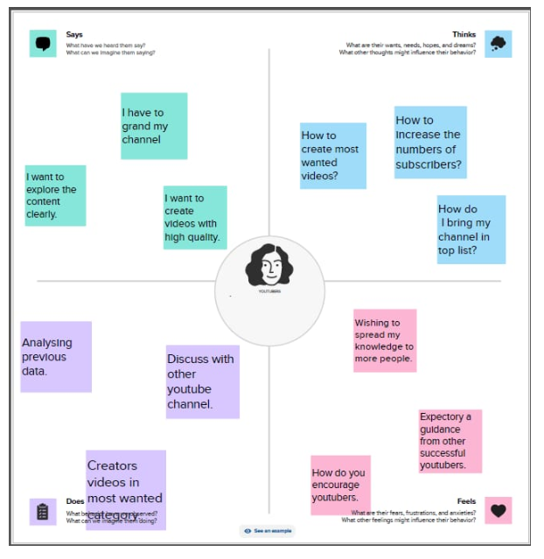

2.2 Ideation & Brainstorming Map

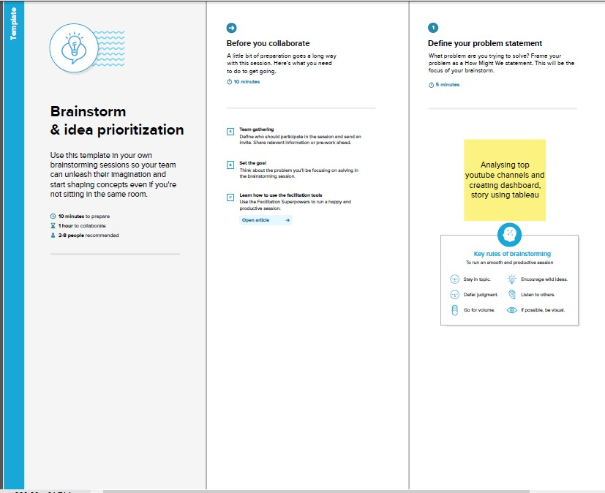

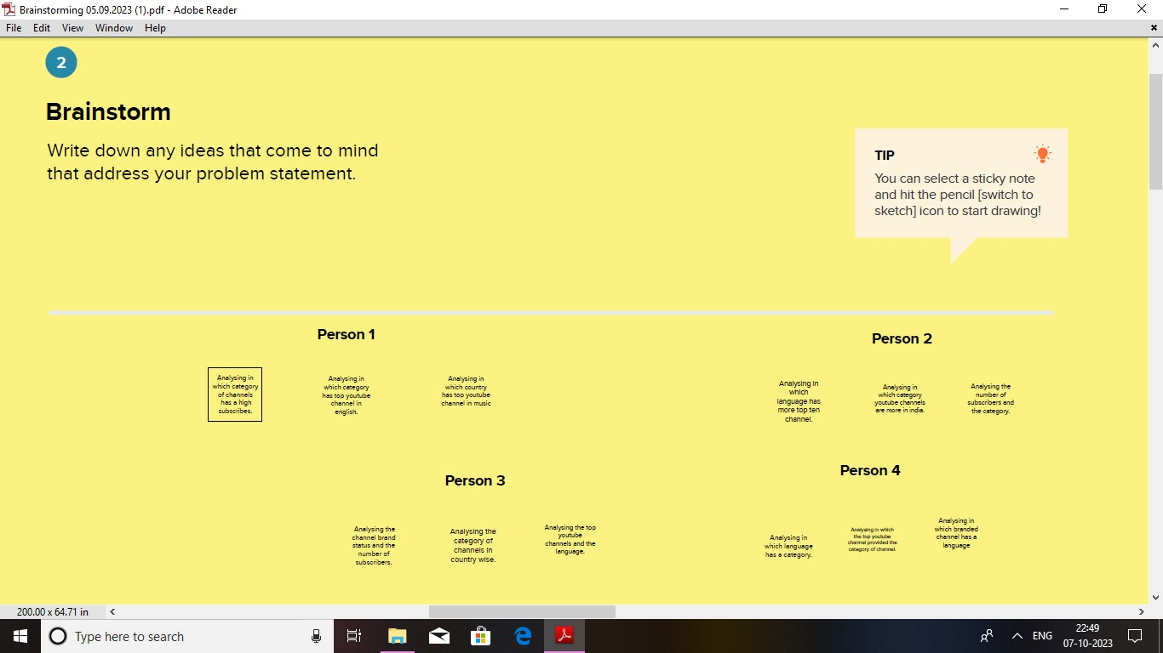

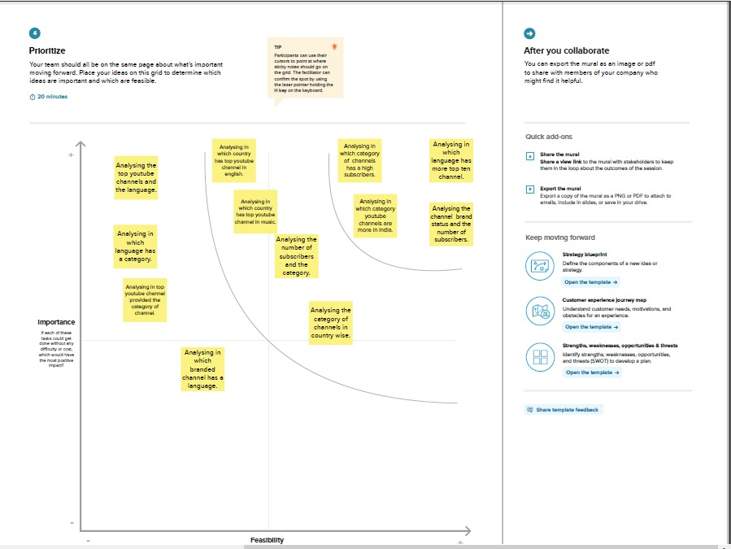

3 RESULT

A literature survey conducted by students exploring you tube channels would typically involve research existing studies, academic papers, and publications related to the topic.

Activity: 1

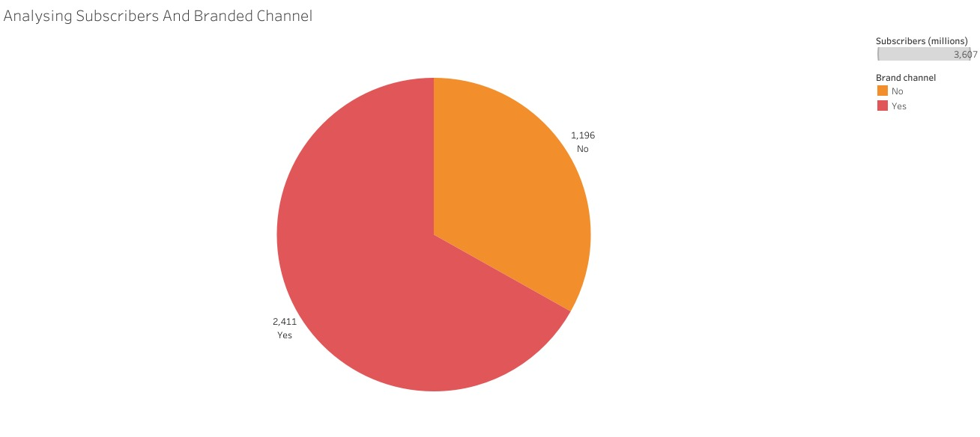

Activity: 2

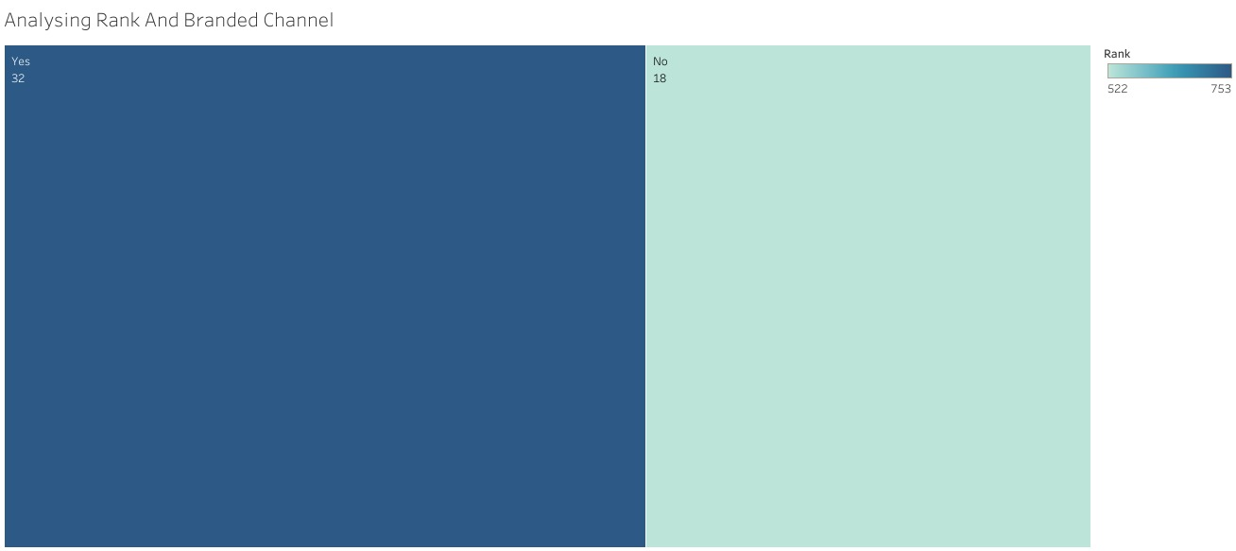

Activity: 3

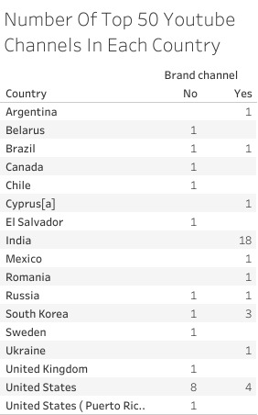

Activity: 4

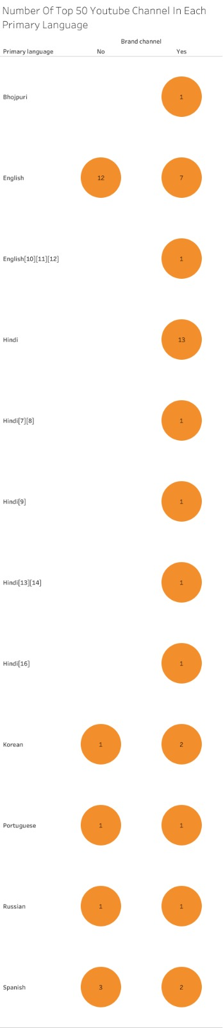

Activity: 5

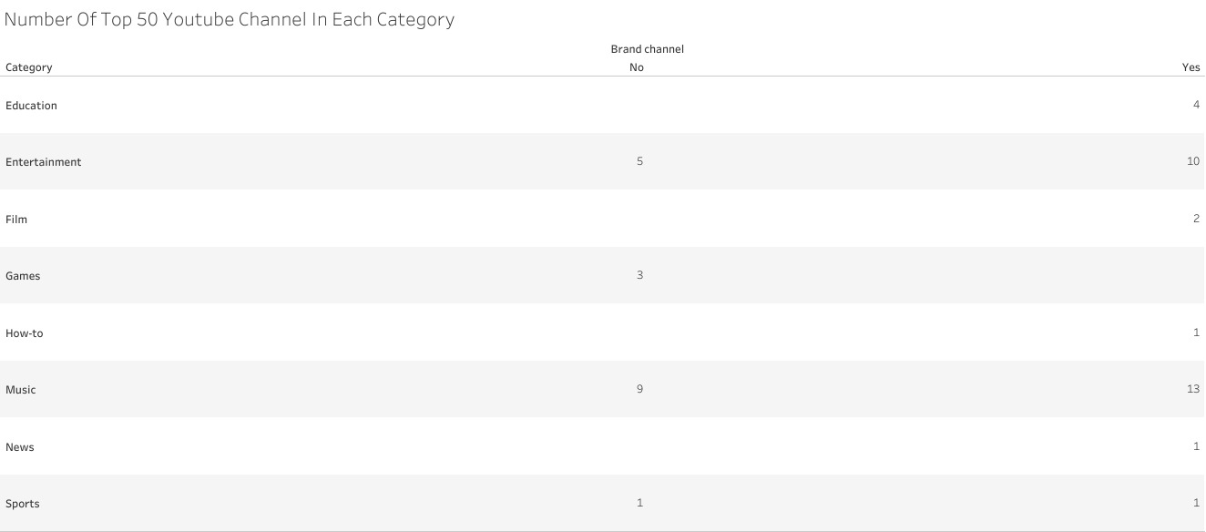

Activity: 6

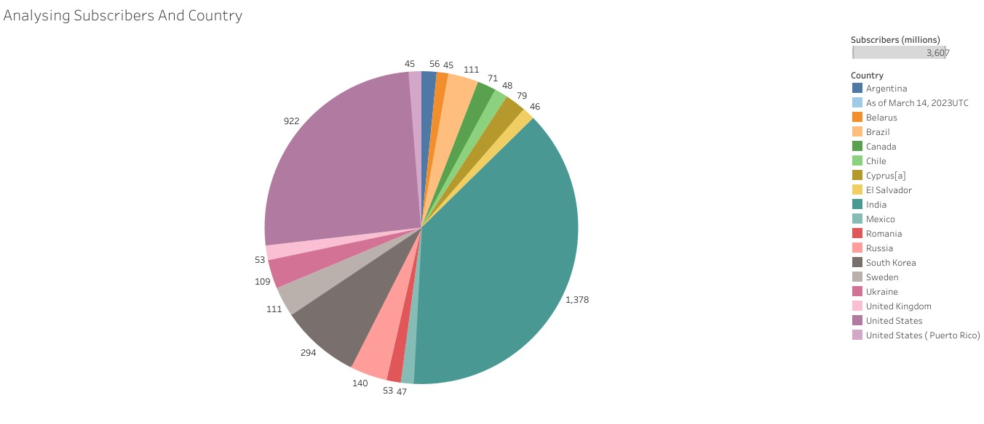

Activity: 7

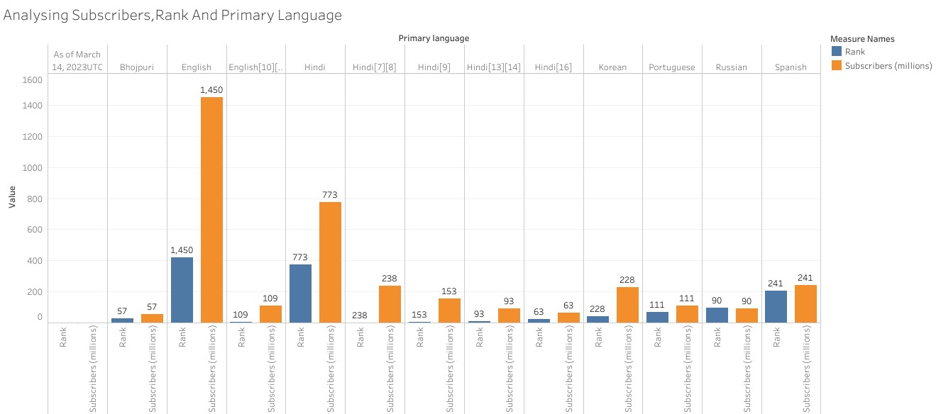

Activity: 8

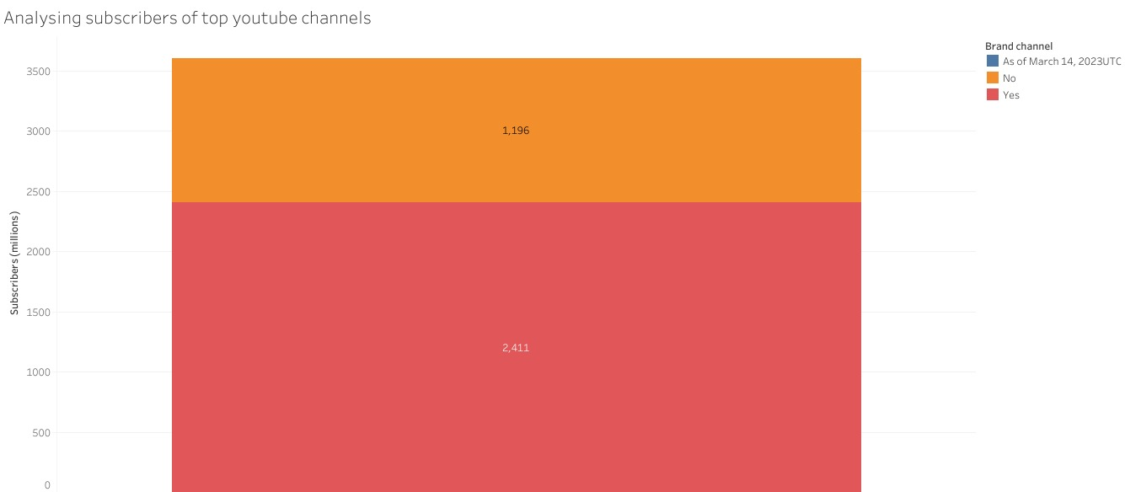

Activity: 9

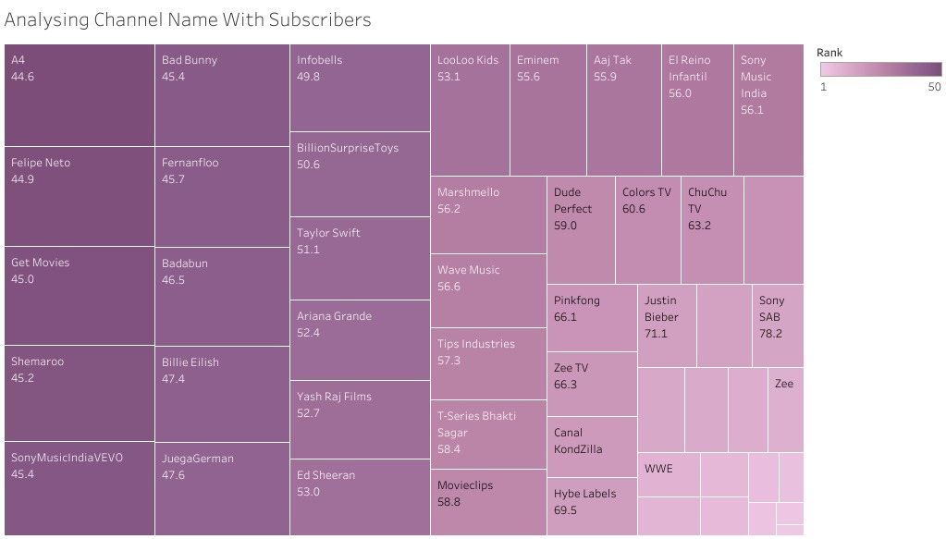

Activity: 10

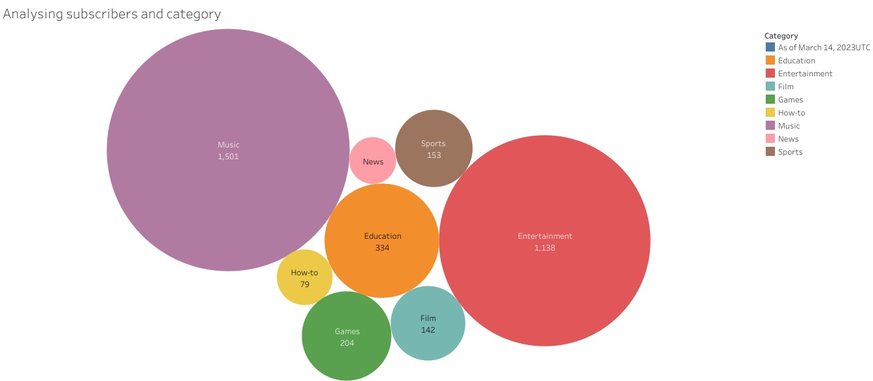

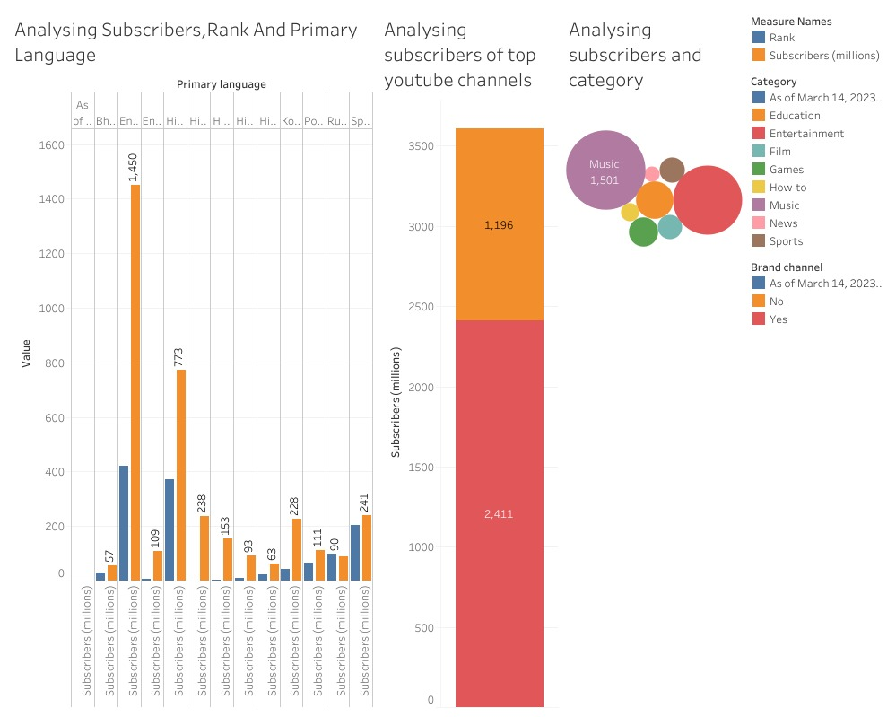

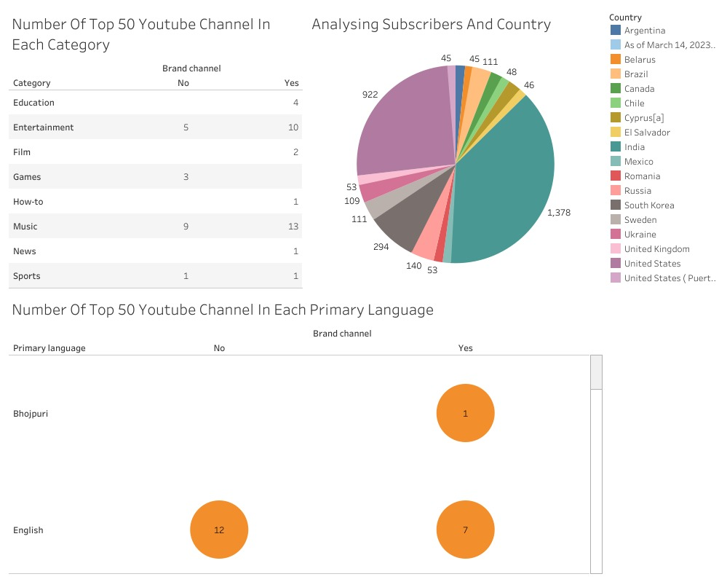

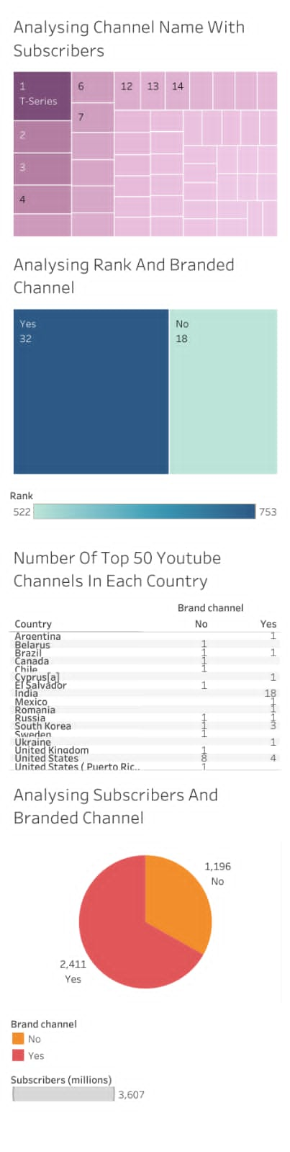

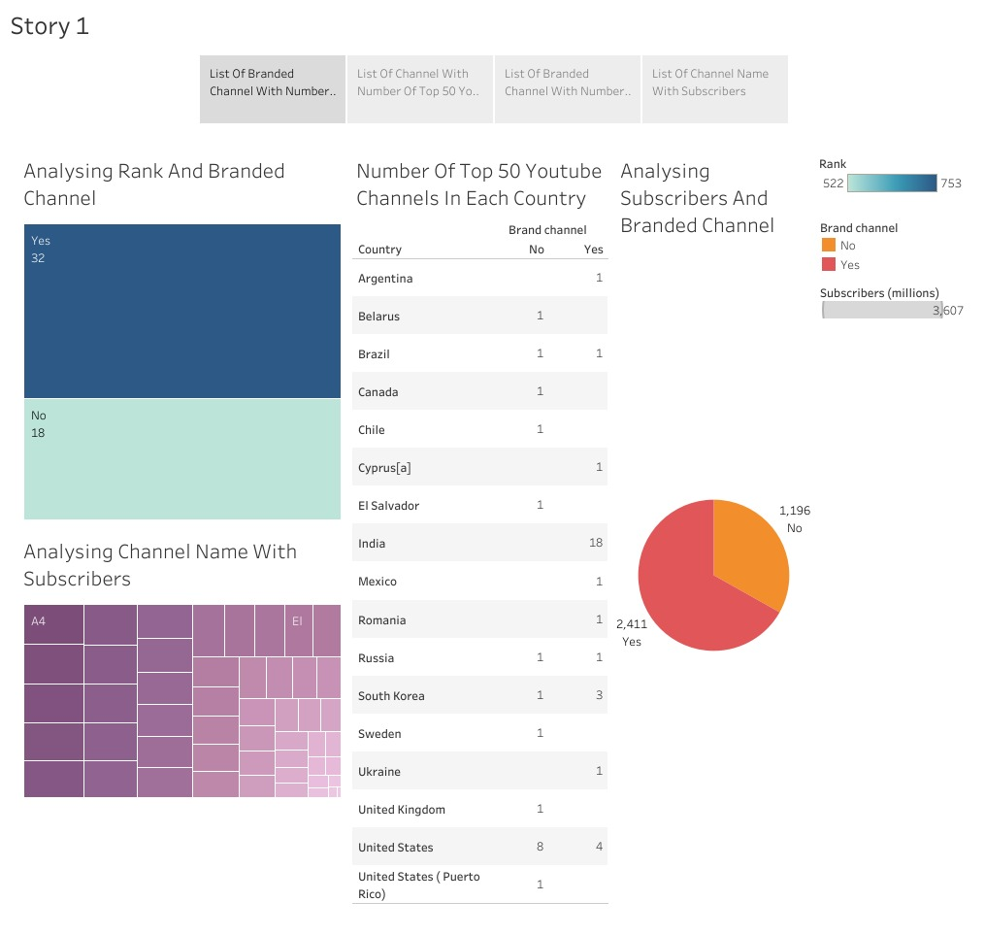

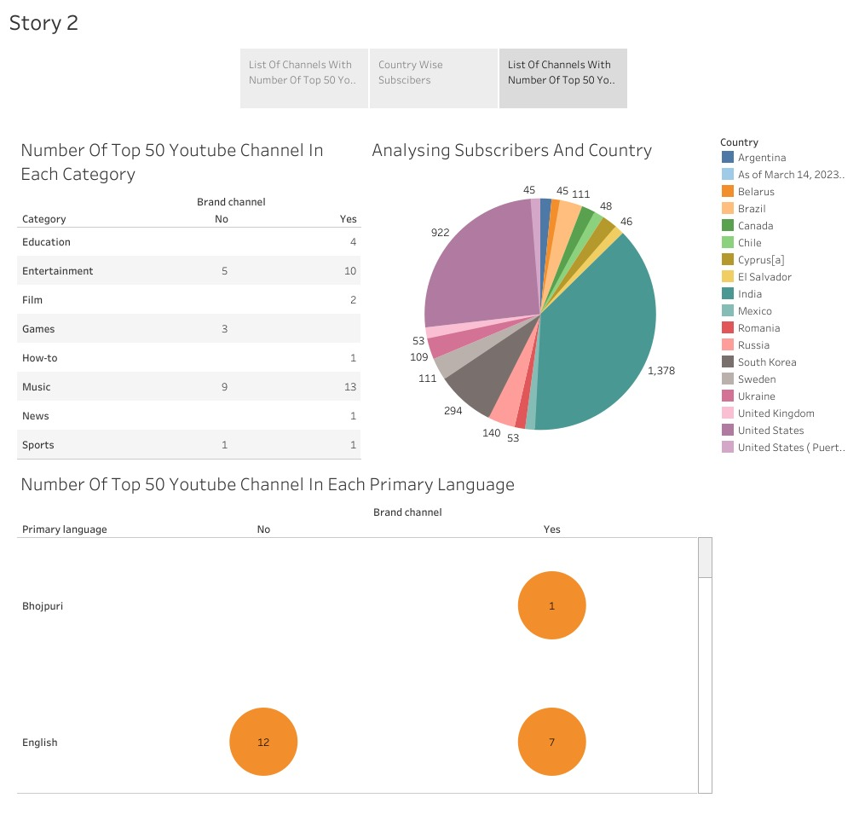

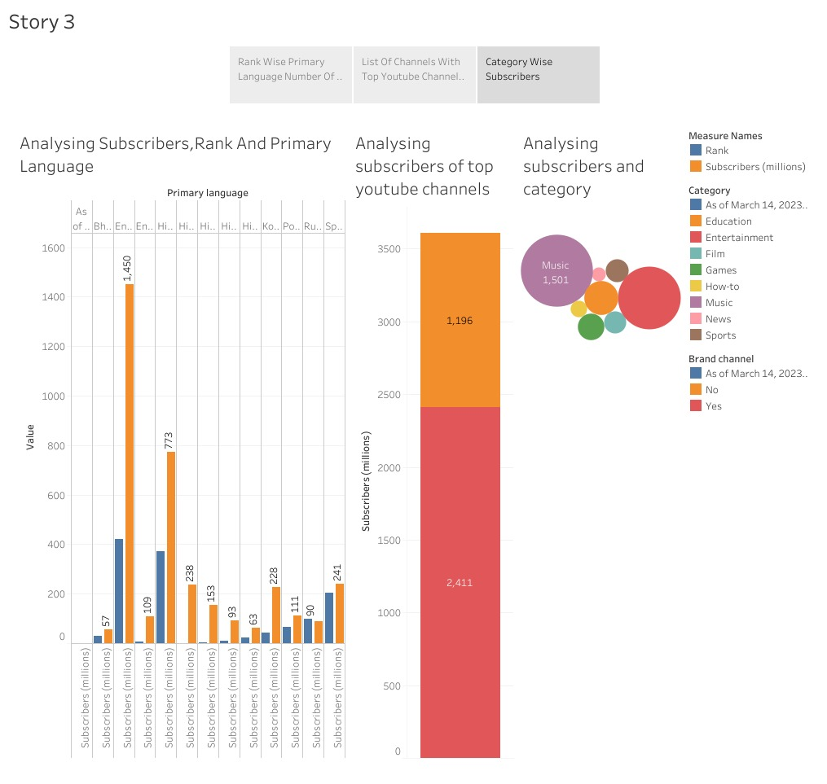

4 ADVANTAGES & DISADVANTAGES

*List of advantages and disadvantages of the proposed solution*  
5 APPLICATIONS

*The areas where this solution can be applied*  
6 CONCLUSION In this report, we have analysed the top 50 youtube channels. We have analysed the number of top 50 youtube channels are in each category, each language and in each country.

7 FUTURE SCOPE

*In future,*